CBIO204 – Fundamentals of Databases
Biotechnology Database Project
Vaccine Research and Development Database

Name: Haneen Mohamed Fathi
ID: 221001966
Under supervision
Dr/ Muhammed Elsayeh

Database: vaccine_rnd_db
DBMS: MySQL
Submission Report

1. Problem Statement, Scope, Assumptions, and Business Rules
The project implements a relational database for managing vaccine research and development activities. It integrates vaccine candidates, antigens, formulations, manufacturing batches, preclinical research, clinical trials, study sites, anonymized participants, laboratory results, and adverse events. The design supports the biotechnology database requirements through strong entities, one-to-many and many-to-many relationships, associative tables, integrity constraints, indexes, views, SQL operations, and an advanced database object (trigger).

In scope
- Vaccine candidate identification and development-stage tracking.
- Antigen management and candidate–antigen associations.
- Formulation and dosage information.
- Manufacturing batch and quality tracking.
- Preclinical study and result management.
- Clinical study and phase management.
- Study site and study-site participation management.
- Anonymized participant enrollment and treatment information.
- Laboratory test definitions and participant laboratory results.
- Adverse-event recording and safety monitoring.
- Integrity enforcement using PK, FK, UNIQUE, CHECK constraints, indexes, and a trigger.

Assumptions
- All records are fictional and intended for academic demonstration.
- Participants are represented by anonymized participant codes rather than identifying information.
- A vaccine candidate can contain one or more antigens.
- A candidate can have multiple formulations, batches, preclinical studies, and clinical studies.
- A clinical study can operate at multiple study sites, and a site can participate in multiple studies.
- A participant can be enrolled in a clinical study through a specific participating site.
- A participant can have multiple laboratory results and adverse events.
- The implementation targets MySQL with the provided SQL syntax.

Major business rules
- Candidate, antigen, formulation, batch, study, site, participant, and test codes are unique.
- Antigen amounts and formulation dose amounts must be positive when provided.
- Batch expiry date must be later than manufacturing date and batch size must be positive.
- Preclinical and clinical study end dates cannot precede their start dates.
- Enrollment completion and participant withdrawal dates cannot precede enrollment dates.
- Enrollment references an existing clinical study–site combination.
- Adverse-event severity, seriousness, vaccine relationship, outcome, and other statuses are restricted to defined values.
- An adverse event can only be inserted when the participant is enrolled in the corresponding clinical study, and its event date cannot be earlier than enrollment.

2. Entities, Attributes, and Keys
Entity | Attributes and key decisions
VACCINE_CANDIDATE | candidate_id PK; candidate_code UQ; candidate_name; vaccine_type; target_disease; target_pathogen; development_status; development_start_date; description
ANTIGEN | antigen_id PK; antigen_code UQ; antigen_name; pathogen; antigen_type; target_protein; description
CANDIDATE_ANTIGEN | candidate_id + antigen_id composite PK/FK; antigen_role; antigen_amount; amount_unit
FORMULATION | formulation_id PK; candidate_id FK; formulation_code UQ; formulation_version; adjuvant; dosage_form; route_of_administration; dose_amount; dose_unit; storage_temperature; formulation_status
BATCH | batch_id PK; formulation_id FK; batch_number UQ; manufacturing_date; expiry_date; batch_size; batch_size_unit; manufacturing_status; quality_status
PRECLINICAL_STUDY | preclinical_study_id PK; candidate_id FK; study_code UQ; study_type; animal_model; start_date; end_date; study_status; objective; conclusion
PRECLINICAL_RESULT | result_id PK; preclinical_study_id FK; parameter_name; parameter_value; unit; result_status; observation
CLINICAL_PHASE | phase_id PK; phase_name UQ; description
CLINICAL_STUDY | clinical_study_id PK; candidate_id FK; phase_id FK; study_code UQ; study_title; protocol_version; start_date; end_date; study_status; primary_objective
STUDY_SITE | site_id PK; site_code UQ; site_name; country; city; site_type; activation_date; site_status
CLINICAL_STUDY_SITE | clinical_study_id + site_id composite PK/FK; site_role; activation_date; enrollment_target; site_status
PARTICIPANT | participant_id PK; participant_code UQ; age_group; sex; eligibility_status; enrollment_date; withdrawal_date; withdrawal_reason
CLINICAL_ENROLLMENT | enrollment_id PK; participant_id FK; clinical_study_id + site_id composite FK; enrollment_date; treatment_group; dose_group; enrollment_status; completion_date
LABORATORY_TEST | test_id PK; test_code UQ; test_name; test_type; specimen_type; unit; reference_range_low; reference_range_high
PARTICIPANT_LAB_RESULT | lab_result_id PK; participant_id FK; clinical_study_id FK; test_id FK; test_date; result_value; result_text; result_status
ADVERSE_EVENT | adverse_event_id PK; participant_id FK; clinical_study_id FK; event_date; event_type; severity; seriousness; related_to_vaccine; outcome; action_taken; resolution_date; description

3. ER Diagram and Relationship Design
The final ER diagram stored in the project diagrams folder. It contains 16 relational entities plus the two database views.
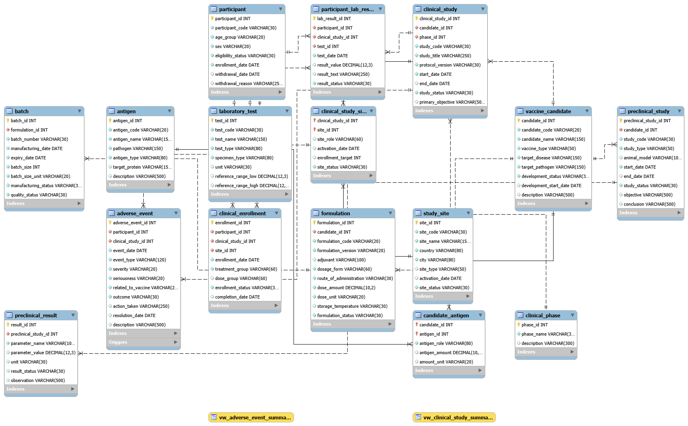

Main relationships
- VACCINE_CANDIDATE 1:N FORMULATION — one candidate can have multiple formulations.
- FORMULATION 1:N BATCH — a formulation can be used to manufacture multiple batches.
- VACCINE_CANDIDATE M:N ANTIGEN — resolved by CANDIDATE_ANTIGEN.
- VACCINE_CANDIDATE 1:N PRECLINICAL_STUDY — a candidate may have multiple preclinical studies.
- PRECLINICAL_STUDY 1:N PRECLINICAL_RESULT — each study can produce multiple measured results.
- CLINICAL_PHASE 1:N CLINICAL_STUDY — each clinical study belongs to one phase.
- VACCINE_CANDIDATE 1:N CLINICAL_STUDY — a candidate can be evaluated in multiple clinical studies.
- CLINICAL_STUDY M:N STUDY_SITE — resolved by CLINICAL_STUDY_SITE.
- PARTICIPANT M:N CLINICAL_STUDY — resolved by CLINICAL_ENROLLMENT; the enrollment also identifies the participating site.
- PARTICIPANT 1:N PARTICIPANT_LAB_RESULT and LABORATORY_TEST 1:N PARTICIPANT_LAB_RESULT.
- PARTICIPANT 1:N ADVERSE_EVENT and CLINICAL_STUDY 1:N ADVERSE_EVENT.
The ERD also shows indexes and the adverse-event validation trigger as database objects associated with the schema.

4. Relational Schema
vaccine_candidate(candidate_id PK; candidate_code UQ; candidate_name; vaccine_type; target_disease; target_pathogen; development_status; development_start_date; description)
antigen(antigen_id PK; antigen_code UQ; antigen_name; pathogen; antigen_type; target_protein; description)
candidate_antigen(candidate_id + antigen_id composite PK/FK; antigen_role; antigen_amount; amount_unit)
formulation(formulation_id PK; candidate_id FK; formulation_code UQ; formulation_version; adjuvant; dosage_form; route_of_administration; dose_amount; dose_unit; storage_temperature; formulation_status)
batch(batch_id PK; formulation_id FK; batch_number UQ; manufacturing_date; expiry_date; batch_size; batch_size_unit; manufacturing_status; quality_status)
preclinical_study(preclinical_study_id PK; candidate_id FK; study_code UQ; study_type; animal_model; start_date; end_date; study_status; objective; conclusion)
preclinical_result(result_id PK; preclinical_study_id FK; parameter_name; parameter_value; unit; result_status; observation)
clinical_phase(phase_id PK; phase_name UQ; description)
clinical_study(clinical_study_id PK; candidate_id FK; phase_id FK; study_code UQ; study_title; protocol_version; start_date; end_date; study_status; primary_objective)
study_site(site_id PK; site_code UQ; site_name; country; city; site_type; activation_date; site_status)
clinical_study_site(clinical_study_id + site_id composite PK/FK; site_role; activation_date; enrollment_target; site_status)
participant(participant_id PK; participant_code UQ; age_group; sex; eligibility_status; enrollment_date; withdrawal_date; withdrawal_reason)
clinical_enrollment(enrollment_id PK; participant_id FK; clinical_study_id + site_id composite FK; enrollment_date; treatment_group; dose_group; enrollment_status; completion_date)
laboratory_test(test_id PK; test_code UQ; test_name; test_type; specimen_type; unit; reference_range_low; reference_range_high)
participant_lab_result(lab_result_id PK; participant_id FK; clinical_study_id FK; test_id FK; test_date; result_value; result_text; result_status)
adverse_event(adverse_event_id PK; participant_id FK; clinical_study_id FK; event_date; event_type; severity; seriousness; related_to_vaccine; outcome; action_taken; resolution_date; description)
Composite relationships are represented by composite keys in CANDIDATE_ANTIGEN and CLINICAL_STUDY_SITE. CLINICAL_ENROLLMENT uses a composite foreign key to guarantee that an enrollment points to a valid study-site participation record.

5. Normalization to 3NF
- 1NF: all attributes are atomic, and repeated concepts such as antigens, batches, study sites, laboratory results, and adverse events are stored as separate rows.
- 2NF: non-key attributes depend on the complete primary key. Relationship-specific attributes such as antigen_role and enrollment_target are stored in their associative relations.
- 3NF: transitive dependencies are reduced by separating concepts such as clinical phases, antigens, formulations, laboratory test definitions, study sites, and clinical studies.
- The M:N relationship between vaccine candidates and antigens is resolved by CANDIDATE_ANTIGEN.
- The M:N relationship between clinical studies and sites is resolved by CLINICAL_STUDY_SITE.
- The M:N relationship between participants and clinical studies is resolved by CLINICAL_ENROLLMENT.
- Laboratory test definitions are kept in LABORATORY_TEST rather than repeated in every participant result.

6. Implementation Details
The implementation uses MySQL. The SQL project is organized into reproducible scripts.
- create_tables.sql: creates vaccine_rnd_db and the 16 core tables, PK/FK constraints, CHECK constraints, UNIQUE constraints, and indexes.
- insert_data.sql: loads synthetic demonstration data, including vaccine candidates, antigens, formulations, batches, preclinical and clinical studies, sites, participants, laboratory tests/results, and adverse events.
- views.sql: creates vw_clinical_study_summary and vw_adverse_event_summary.
- trigger.sql: creates trg_validate_adverse_event_date.
- queries.sql: demonstrates SELECT, filtering, JOINs, multi-table JOINs, aggregation, HAVING, subqueries, INSERT, UPDATE, and DELETE.
The supplied dataset contains 10 vaccine candidates, 10 antigens, 10 batches, 10 preclinical studies/results, 10 clinical studies, 10 study sites, 10 participants, 10 clinical enrollments, 10 laboratory tests/results, and 10 adverse-event records (with the candidate–antigen and study-site relationships intentionally varying in cardinality).

7. Views and Advanced Database Object

View 1 — vw_clinical_study_summary
Summarizes each clinical study with study code, candidate name, clinical phase, study status, number of distinct enrolled participants, and number of participating sites.

View 2 — vw_adverse_event_summary
Groups adverse events by candidate, study, severity, seriousness, relationship to the vaccine, and event count.

Trigger — trg_validate_adverse_event_date
A BEFORE INSERT trigger on ADVERSE_EVENT checks that the participant has an enrollment record in the same clinical study. It also prevents an adverse-event date earlier than the participant's enrollment date and raises a SQLSTATE 45000 error when the rule is violated.

8. Sample SQL Operations

Basic SELECT
SELECT * FROM vaccine_candidate;

Filtering
SELECT candidate_code, candidate_name, development_status FROM vaccine_candidate WHERE development_status IN ('Phase I','Phase II','Phase III');

JOIN
SELECT vc.candidate_code, vc.candidate_name, f.formulation_code, f.dose_amount, f.dose_unit FROM vaccine_candidate vc JOIN formulation f ON vc.candidate_id = f.candidate_id;

Multi-table JOIN
SELECT cs.study_code, vc.candidate_name, cp.phase_name, cs.study_status FROM clinical_study cs JOIN vaccine_candidate vc ON cs.candidate_id = vc.candidate_id JOIN clinical_phase cp ON cs.phase_id = cp.phase_id;

Aggregation
SELECT vc.candidate_code, COUNT(f.formulation_id) AS formulation_count FROM vaccine_candidate vc LEFT JOIN formulation f ON vc.candidate_id = f.candidate_id GROUP BY vc.candidate_id, vc.candidate_code;

HAVING
SELECT clinical_study_id, COUNT(*) AS participant_count FROM clinical_enrollment GROUP BY clinical_study_id HAVING COUNT(*) >= 2;

Subquery
SELECT candidate_code, candidate_name FROM vaccine_candidate WHERE candidate_id IN (SELECT candidate_id FROM formulation GROUP BY candidate_id HAVING COUNT(*) > (SELECT AVG(formulation_count) FROM (SELECT COUNT(*) AS formulation_count FROM formulation GROUP BY candidate_id) x));

View
SELECT * FROM vw_clinical_study_summary;

Lab-result JOIN
SELECT p.participant_code, lt.test_name, plr.test_date, plr.result_value, plr.result_status FROM participant_lab_result plr JOIN participant p ON plr.participant_id = p.participant_id JOIN laboratory_test lt ON plr.test_id = lt.test_id;

INSERT / UPDATE / DELETE
INSERT INTO antigen (...) VALUES (...); / UPDATE antigen SET description = 'Updated demonstration record.' WHERE antigen_code = 'AG011'; / DELETE FROM antigen WHERE antigen_code = 'AG011';

9. Testing Plan and Expected Results
ID | Test | Expected result
T01 | Insert valid vaccine candidate | Row inserted successfully.
T02 | Duplicate candidate_code | UNIQUE constraint rejects duplicate.
T03 | Invalid development status | CHECK constraint rejects unsupported value.
T04 | Invalid batch expiry date | CHECK constraint rejects expiry not later than manufacturing date.
T05 | Invalid foreign key | Child record referencing a nonexistent parent is rejected.
T06 | Negative dose or batch size | CHECK constraint rejects non-positive value.
T07 | Valid clinical enrollment | Enrollment succeeds when the study-site combination exists.
T08 | Adverse event for non-enrolled participant | Trigger raises an exception and prevents insertion.
T09 | Adverse event before enrollment date | Trigger raises an exception and prevents insertion.
T10 | View execution | Both views return summary rows from the loaded data.

10. Limitations and Future Improvements
- The dataset is fictional and intended for academic demonstration.
- Authentication, authorization, and role-based database permissions are outside the current scope.
- Participants are anonymized, but a production system would require stronger privacy, consent, and audit controls.
- The current design does not include automated vaccine inventory forecasting or manufacturing equipment integration.
- Future improvements could include a web/mobile user interface, role-based access control, audit history, automated dashboards, laboratory-system integration, batch release workflows, and real-time clinical safety reporting.

11. Conclusion
The Vaccine Research and Development Database provides a normalized relational model for a connected biotechnology workflow. It covers candidate and antigen management, formulation and manufacturing, preclinical evaluation, clinical development, study sites, participant enrollment, laboratory testing, and adverse-event monitoring. The implementation demonstrates primary and foreign keys, composite relationships, UNIQUE and CHECK constraints, indexes, 3NF normalization, SQL operations, two analytical views, and an advanced validation trigger. The resulting database provides a structured foundation for a future full vaccine R&D information system.

12. References
- CBIO204 – Fundamentals of Databases, Biotechnology Database Project Guidelines, provided course document.
- MySQL Documentation — MySQL Reference Manual, Oracle Corporation.
- Project ERD: ERD Pdf.pdf (submitted project diagram).

– ER Diagram
The complete ERD is included in the project submission as ERD.pdf and is stored in the diagrams folder of the GitHub repository. The diagram covers the tables, attributes, relationships, indexes, trigger, and views represented by the implementation.
Core relationship map: Candidate → Formulation → Batch; Candidate ↔ Antigen via Candidate_Antigen; Candidate → Preclinical_Study → Preclinical_Result; Candidate → Clinical_Study → Clinical_Study_Site ← Study_Site; Participant → Clinical_Enrollment; Participant → Participant_Lab_Result ← Laboratory_Test; Participant → Adverse_Event; Clinical_Phase → Clinical_Study.

